Concepts of Operation
Human Resource Management
This document describes vary concepts of stakeholder about HRM system. By accepting all contents written on this article, stakeholders will get an agreement on system’s requirements.
6/6/2012

Table of Contents
I. Introduction 5
1.1 Product Overview 5
1.2 Document 5
1.2.1 Scope 5
1.2.2 Document Overview 5
II. Current System 6
2.1 Background, Objectives, and Scope 6
2.2 Operational Policies and Constraints 6
2.3 Description of Current System 6
2.4 Current Users and Stakeholders 6
2.5 Current Support Environment 7
III. Justification and Description of Changes 7
3.1 Justification of Changes 7
3.2 Description of Desired Changes 7
3.3 Priorities among Changes 8
3.4 Changes Considered But Not Included 8
IV. Proposed System 8
4.1 Backgrounds, Objectives, and Scope: 9
4.2 Operational Policies and Constraints 9
4.3 Description of the Proposed System 9
4.3.1 General Business Processes 9
4.3.1.1 General Business Process 9
4.3.1.2 General data flow 11
V. Summary of Impacts 36
5.1 Operational Impacts 36
5.2 Organizational Impacts 36
5.3 Impacts during Development 36
VI. Analysis of the Proposed System 36
6.1 Summary of Improvements 37
6.2 Disadvantages and Limitations 37
6.3 Alternatives and Trade-offs Considered 37

Revision Table
Author | Date | Reason for changes | Version
Tan Tran | 11/10/2011 | Add information about current system, including: 2.1, 2.2, 2.3 | 1.0
Quyet Nguyen | 12/10/2011 | Add information into section 2 | 1.0.1
KhoiNguyen Dinh | 24/10/2011 | Review and translate document into Vietnamese for presenting to customers | 1.0.2
Team | 27/10/2011 | Update section 5 | 1.0.3
Tung Nguyen, Nguyen Dinh | 30/10/2011 | Update section 7 | 1.0.4
Quyet Nguyen  Loc Phan | 30/10/2011 | Update section 6 | 1.0.5
Nguyen Dinh | 31/10/2011 | Review and fix some minor bugs | 1.0.6
Nguyen Dinh | 31/10/2011 | Update section 1 and description for each section, update section 2 | 1.0.7
Loc Phan | 31/10/2011 | Fix section 3 | 1.0.8
Nhung Huynh | 31/10/2011 | Fix section 5, add business processes | 1.0.9
Nguyen Dinh | 31/10/2011 | Review and fix some minor bugs | 1.0.10
Quyet Nguyen | 2/11/2011 | Fix some bugs based on team's request | 1.1
Tung Nguyen | 2/11/2011 | Edit context for Wage Progress | 1.1.1
Nhung Huynh | 2/11/2011 | Add figures into section 5 | 1.1.2
Dang Nguyen | 2/11/2011 | Update user of current and proposed system | 1.1.3
Tuong Nguyen | 2/11/2011 | Update Personal Information Management | 1.1.4
Tuong Nguyen | 3/11/2011 | Fix and update Personal Information Management | 1.1.5
Quyet Nguyen | 3/11/2011 | Update section 6 | 1.1.6
Quyet Nguyen | 3/11/2011 | Review and fix some minor bugs | 1.1.7
Tuong Nguyen | 4/11/2011 | Complete Personal Information Management | 1.1.8
Nhung Huynh | 5/11/2011 | Fix scenarios | 1.1.9
Quyet Nguyen |  | Review  Update general process | 1.1.10
Nhung Huynh | 5/11/2011 | Fix scenarios | 1.1.11
Dang Nguyen | 6/11/2011 | Update functions data flow diagram, work registration process | 1.1.12
Nhung Huynh | 6/11/2011 | Fix some bugs | 1.1.13
Nhung Huynh | 7/11/2011 | Fix scenarios: font, color, figures | 1.1.14
Nhung Huynh | 8/11/2011 | Review with team and fix some minor bugs | 1.2
Nguyen Dinh | 8/11/2011 | Review and check decoration bugs | 1.2.1
Dang Nguyen | 10/11/2011 | Fix data flow diagram | 1.2.2
Quyet Nguyen | 10/11/2011 | Describe data flow diagram, fix scenarios related to Personal Information Management | 1.2.3
Nguyen Dinh | 10/11/2011 | Review and fix bugs on description of data flow diagram | 1.2.4
Tuong Nguyen, Loc Phan, Tan Tran | 20/12/2011 | Review all content on this document | 1.2.5
Nguyen Dinh | 05/08/2012 | Review and translate all content into English | 1.2.6

Introduction

Product Overview
Currently, staffs working on Human Resource Planning and Managing Department (HRP&MD) face some unsolvable problems when using Microsoft Excel to manage human resource. Therefore, HRP&MD needs a program to solve these problems. The new human resource management (HRM) program is a gigantic system and requires developing team to understand its business, management processes utterly. Besides, the program must provide many more extra functions, such as the ability to associate with other departments and add more functions if required by customers. In addition, this program is strictly used within Vanlang University only; related documents are secured and prohibited from using outside.
This table describes project’s stakeholders:
Stakeholders | Responsibility in Managing
Management groups belong to HRP&MD | - Take responsible for business processed in HRM  - Provide business information to requirement engineers of development team.  - Provide forms, and related documents  - The direct user of HRM
Development Team | - Take full responsible for developing HRM project (Getting requirements, system design, gather related documents)
Software Development Center | - Provide tools and software needed to design HRM software product  - Support development team about system features and implementing skills

Document

Scope
“Concepts of Operation” document describes desired characteristics of the proposed system based on stakeholders’ points of view. These sections bellowed identify the proposed HRM system, and provide an overview about documents and entire system.

Document Overview
We can consider this document as a communication tool among users, development team, and other stakeholders. Concepts proposed in this document are the result of an analysis about risks and customers’ requirements for a HRM system that is easy-to-use and satisfy common requirements. This document includes seven sections
- Section 1: Introduces system overview and this document
- Section 2: Describes current system and related information
- Section 3: Describes justification and changes based on problems when using old system
- Section 4: of this document provides proposed system information
- Section 5: describes concepts of operation
- Section 6: Summarizes operational impacts, organization throughout development period
- Section 7: Analysis of the proposed system

Current System

Background, Objectives, and Scope
HRPD&DM staffs operate the current human resource management system manually in inputting and processing data, statistic and saving database into paper documents based on some main functions: Recruitment, Personal Information Management, Employee Labor Contract Management, Insurance Information Management, Assessment Management, Employee Labor Management, and Payroll Management.
This system will support HRP&MD staff to manage working staffs’ information, in addition to store retired staffs, update employee records each year, make summary report on the working progresses and results for university’s administrators and other units.

Operational Policies and Constraints
With modern operational processes, all documents together with related information are stored within Van Lang University (VLU). Transporting information among departments is based on paper documents or notification emails.
Currently, HRP&MD staffs have to input a staff’s information after he (she) has been employed and started to work at VLU. Other departments cannot edit staff’s information, except sending reports to HRP&MD for changing information.

Description of Current System
The current system consists: training department, accounting department, human resource planning and managing department, and other departments.
Human resource information is stored in paper files.
Major Functions of the current system
No. | Function | Description
1 | Staff information management | - Detailed information management  - Expanded information management  - Edit, update information
2 | Report, statistic | - Template management  - Staff Reporting in timely manner (month, year)

Current Users and Stakeholders

Actor | Roles and Responsibilities
Training Department | - Plan for recruitment  - Manage teaching hours of official and visiting lecturers.  - Manage and evaluate staff labor
Human Resource Planning and Managing Department | - Plan for recruitment  - Create promotion paper to confirm employed candidates for the head master to sign.  - Create employee’s contract  - Register insurance for employee  - Manage and evaluate staff labor  - View, statistic, and report employee information
Unit | - Plan for recruitment  - Manage and evaluate staff labor  - View, statistic, and report employee information
Accounting Department | - Plan for recruitment  - Manage and evaluate staff labor  - Update employee income

Current Support Environment
Paperwork environment: mostly in paper

Justification and Description of Changes

Justification of Changes
Disadvantages of the current system
  - Non-synchronized data among sections
  - Difficult to manage data when stored in variable places
  - Difficult in working with data saved in different locations
  - Hard to follow, and update data
  - Spend too much time and too bored to input data
  - Same data sometimes do not save in the same place
Customers’ desires in the proposed system
- Automation in working
- Authentication in accessing data
- Create a friendly, easy, and simply to operate working place
- Can create and manage decision, plan, template
- Create a data relationship so that user can track them easily
- Main functions will be divided into small groups for managing
- Give an opportunity to dynamic job rotation for employees

Description of Desired Changes

Improvement | Description
Provide data inputting automatically via catalog | - This will let user choose information from a catalog instead of typing in
System change | - Change from current system (excel) to a management software
Changes in user interface | - All management processes will be operate on proposed system, plus some improvements in managing human resource.  - All functions will be identical.
Supports | - Development team will provide a user manual
Store data in one place | - All system data will be stored in one database.
Provide function to create decisions, plans, templates | - The proposed system will provide some templates for inputting data and update those information frequently
Other changes | - Will update if existed

Priorities among Changes
Improvement | Level
Provide automation in inputting  Gather information into common list | Average
System change | High
Changes in user interface | High
Supports | High
Store data in one place | High
Provide function to create decisions, plans, templates | Average
Other changes | Average

Changes Considered But Not Included
Considered Improvements | Reason
Notify when a contract is out of date or increase income | This function will be developed in the next version
Link information to university official web page | Not important

Proposed System
In managing human resource manually at a university, Human Resource Planning and Managing Department staff has to face so many problems. This system will resolve current problems and help HRP&MD closely to watch for personal and related information of an employee through working and researching progress at VLU.
Development team is ready to provide changes at any time follow customers’ requests through development time.

Common system requirements:
- Set a human resource system including recruitment, personal information management, labor management etc. based on university’s specific requirements.
- Integrate data from integrated accounting system and all other units.
- Create a database specified for human resource.
- Must have report for human resource analysis of university, unit, etc.

Backgrounds, Objectives, and Scope:
The proposed system must operate in computer with automatic process; all input, processing, and statistic process must be operating on this software. In addition, the proposed system has tools supporting import, export, and report.
The proposed system will manage human resource in both two campuses, and database will be stored in campus one. Both staff on campus one and two will access to the same database via cables, for connecting and synchronizing data between campus one and two.
Mainly purpose of the system is to optimize current human resource processes, simplify works, high performance to save time, and resources.
Must analyze and design the proposed system to be suitable to the current infrastructure and management policies.

Operational Policies and Constraints
- Database is stored in campus.
- Operations based on internal connection between two campuses.
- Must backup database in a timely manner
- User must be authenticated before using
- System must be secured to store users’ password, increase security
- Data must be consistent, unique, and updated usually.

Description of the Proposed System

General Business Processes

General Business Process
This is a general process of a candidate who passed Recruitment. Then he/she becomes an employee going through Income management, in addition to required documents and the person who is in charge.

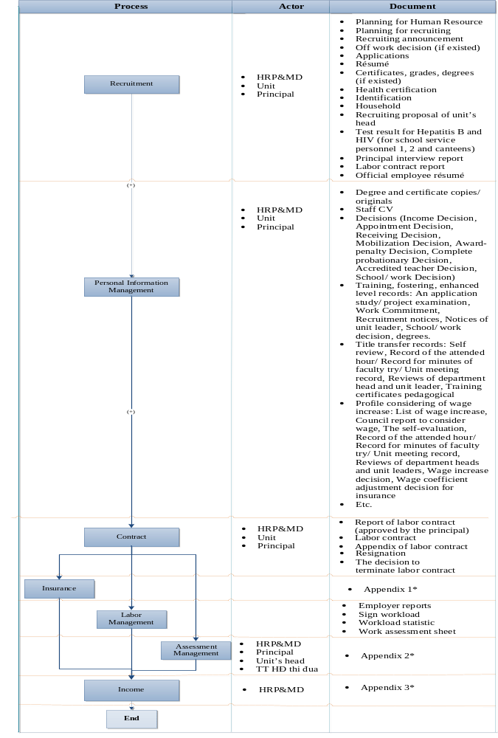
Figure 1: General Business Process
Appendix 1*:
- The declaration of issued papers
- Monitoring file of insurance process
- Template: 01A-TBH, 03A-TBH, 66A, 67A-HD, 68A, 69A, 70A-HD
- Book/ cover of insurance
Appendix 2*:
- The sum results of performance evaluation
- Bill number 19
Appendix 3*:
- An application for leave: school, illness, pregnancy, maternity leave for personal
- Teaching hour (data from Training Department)
- Grading wage (data from Training Department)
- Dossiers of registration tax code
- Dossiers of registration for family allowances
- Loan profile

General data flow

Through main functions in HRM, they interact with each other via separate information
1
RECRUITMENT
2
PIM
3
LABOR CONTRACT
5
LABOR
4
INSURANCE
6
ASSESSMENT
7
INCOME
Accounting F
Training F
Unit
Recruitment result
workload and homeroom teach
Recruitment request, assessment
Candidate’s info, report
Lecturer information
Update personal info
Plan for HR
Working date
Workload
Result, Performance
Wage stamp
Income table
HR Info
Decision
Contract type

Result
The earning factors
Personal income tax file

Social insurance premiums
Workload
Working date

Performance
Award,
Penalty

HR info
HR info
Salary ratio
Update social insurance
Contract type
Insurance premiums
Contract signed file
Update title, level, and current work
Infor HR, personal income tax
Individual
Assessment
File

Relationship between unit and function

Actor
Relationship among functions
Legend
Function
Inherit

Figure 2: General data flows
    - Functions of Human Resource Management
      - System Management
- Create account
- Change password
- User Management
- Data change log management
- User decentralization
- Delete user account
This function will be developed together with Personal Information Management
      - Recruitment Management
This function will be developed in the next version.
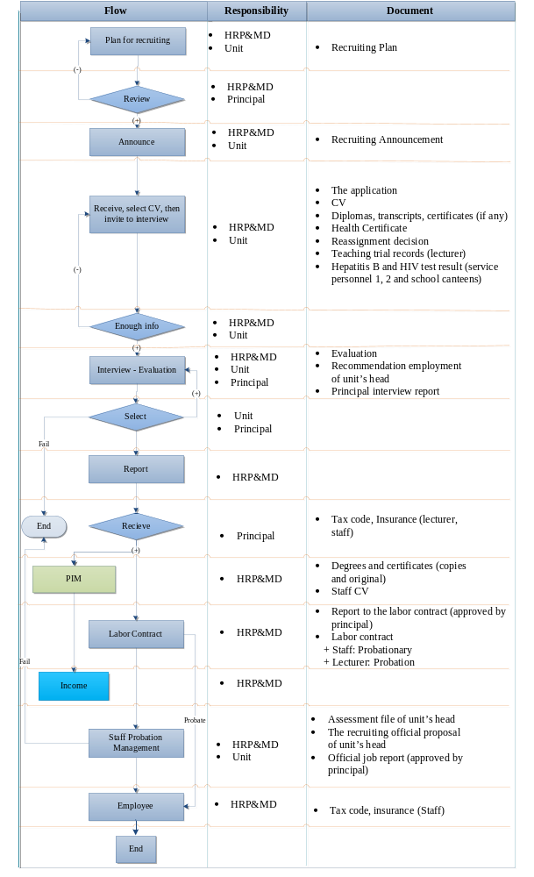
Figure 3: Recruitment process
      - Labor Contract Management
- Manage contract types (probation contract, staff internship contract, period official contract, non-period official contract) and decisions.
This function will be developed in the next version

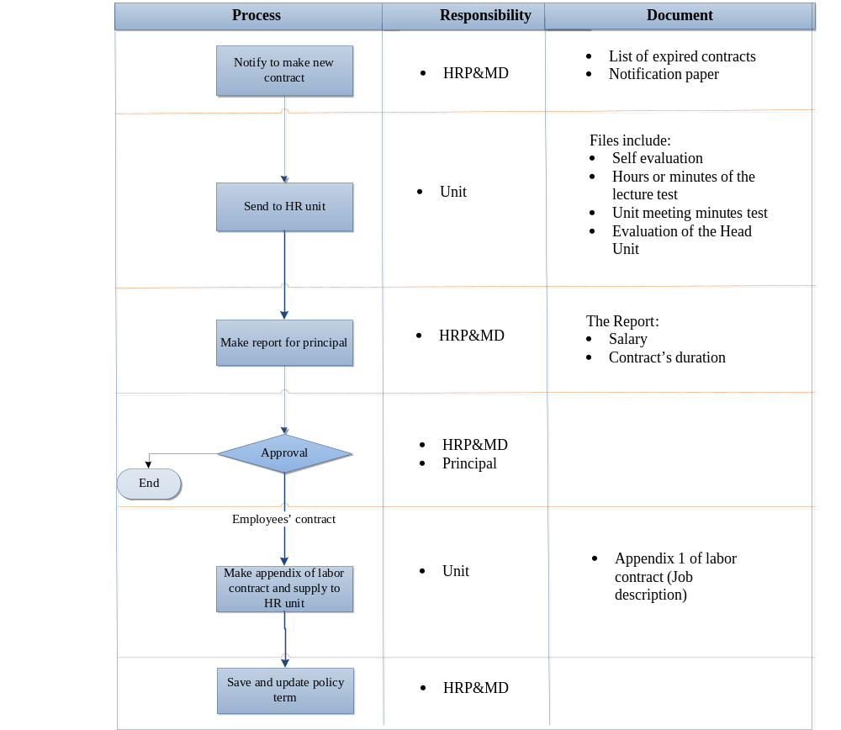
Figure 4: Labor contract management process
      - Insurance Management
- Manage clinic and social insurance notebook
This function will be developed in the next version
      - Assessment Management
- Manage HR evaluation
This function will be developed in the next version
      - Labor Management
This function will be developed in the next version

      - Report – Statistic Management
- Statistic and report in a timely manner (base on current templates)
- Statistic and report following users’ options
- Print data
- For more information, view [HRM]InformationCategories
      - Income Management
This function will be developed in the next version
      - Manage Personal Information Management
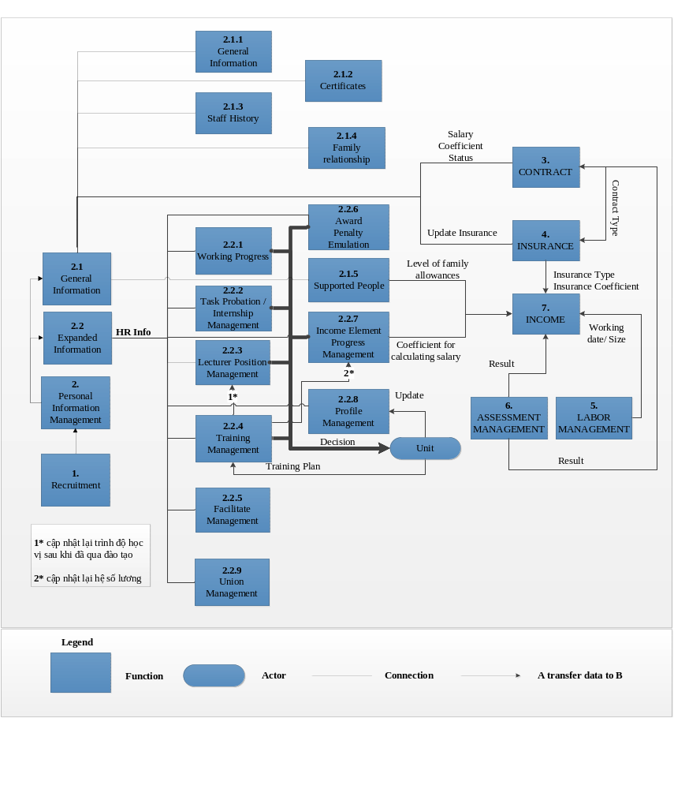Figure 5: Personal Information Management decomposition view
GHI CHÚ:
2.2.2 → Unit
- Decision: Mobilization/ appointment new positions
2.2.3 → Unit
- Notify, Position transfer checking (Lecturer), Official labor contract checking.
- Decision: position transferring (Lecturer)
- Notify to sign official labor contract (Lecturer)
Unit → 2.2.3
- Self-evaluation file
- Class attendance record/ Lecture test/ Unit meeting
- Comment paper, recommendation of Unit Head
2.2.4 → Unit
- Decision: Decision of staff/ lecturer salary modification
2.2.5 → Unit:
- Decision: Send for training
Unit →2.2.5
- Decision: Training Plan
2.2.7 → Unit:
- Decision: Award/ Penalty
2.2.8 → Unit:
- Decision: Rising salary adjustment

        - General Scenario
          - Manage Personal Information Management Through Scenario
Scenario
Assumption | System allows user to update all information in Personal Information Management
Actor | Staff of HRP&MD
Step | - Log in to the System  - Choose Personal Information Management  - Choose detailed information management  - Input necessary information  - Save  - Choose expanded information management  - Input necessary information  - Click save

          - Scenario for Adding New Information in Personal Information Management
Generally, when adding new information, user must input basic information (name, year of birth, address etc…) However, other information (detailed information and expanded information) can be left blank and updated later.

Scenario
Assumption | System allows user to create Personal Information Management
Actor | Staff of HRP&MD
Step | - Log in to the System  - Choose Personal Information Management  - Create new employee  - Input information  - Click save

          - Scenario for Editting Information in Personal Information Management
Scenario
Assumption | System allow user update chi tiết Personal Information Management
Actor | Staff of HRP&MD
Step | - Log in to the System  - Choose Personal Information Management  - Choose object to update  - Input changes  - Click save

        - Manage general information
This function allows HR record employee detailed information

          - General Information
            - Description
Refer to: [HRM] InformationCategories.xlsTTC&TTMR 2.1.1
            - Scenario
Scenario
Assumption | System allows user to update general information
Actor | Staff of HRP&MD
Step | - Log in to the System  - Choose Personal Information Management  - Choose Manage general information  - Update general information  - Click save

          - Certificates
            - Description
Refer to: [HRM] InformationCategories.xlsTTC&TTMR 2.1.2
            - Scenario
Scenario
Assumption | System allows user to update employee certficates
Actor | Staff of HRP&MD
Step | - Log in to the System  - Choose Personal Information Management  - Choose Manage general information  - Update Information in certificate  - Click save

          - Staff history
            - Description
Refer to: [HRM] InformationCategories.xlsTTC&TTMR 2.1.3
            - Scenario
Scenario
Assumption | System allows user to update staff history in Personal Information Management
Actor | Staff of HRP&MD
Step | - Log in to the System  - Choose Personal Information Management  - Choose Manage general information  - Update staff history  - Click save

          - Family Relationship
            - Description
Refer to: [HRM] InformationCategories.xlsTTC&TTMR 2.1.4
            - Scenario

Scenario
Assumption | System allows user to update family relationship in PIM
Actor | Staff of HRP&MD
Step | - Log in to the System  - Choose PIM  - Choose Manage general information  - Update Family Relationship  - Click save

          - Supported People Management
            - Description
Refer to: [HRM] InformationCategories.xlsTTC&TTMR 2.1.5
            - Scenario
Scenario
Assumption | System allows user to Manage employee supported people for family allowances.
Actor | Lecturer, Staff
Step | - Log in to the System  - Choose Personal Information Management  - Choose Expanded Information Management  - Choose Supported People Management  - Update information  - Save

        - Manage expanded information
          - Manage Working Progress
This function allows user to manage working progress
            - Description
Refer to: [HRM] InformationCategories.xlsTTC&TTMR 2.2.1
            - Scenario
Scenario 1
Assumption |  | System allows user to update working progress before working at VLU
Actor |  | Staff of HRP&MD
Step |  | - Log in to the System  - Choose Personal Information Management  - Choose Detailed Information Management  - Choose employee  - Input information  - Click save
Scenario 2
Assumption | System allows user to update working progress after working at VLU
Actor | Staff of HRP&MD
Step | - Log in to the System  - Choose Personal Information Management  - Choose Expanded information  - Choose Working Progress  - Input information  - Click save

          - Manage Lecturer Probation
This function allows user to create notification, create position transfer profile for probationary faculty.
            - Business Process
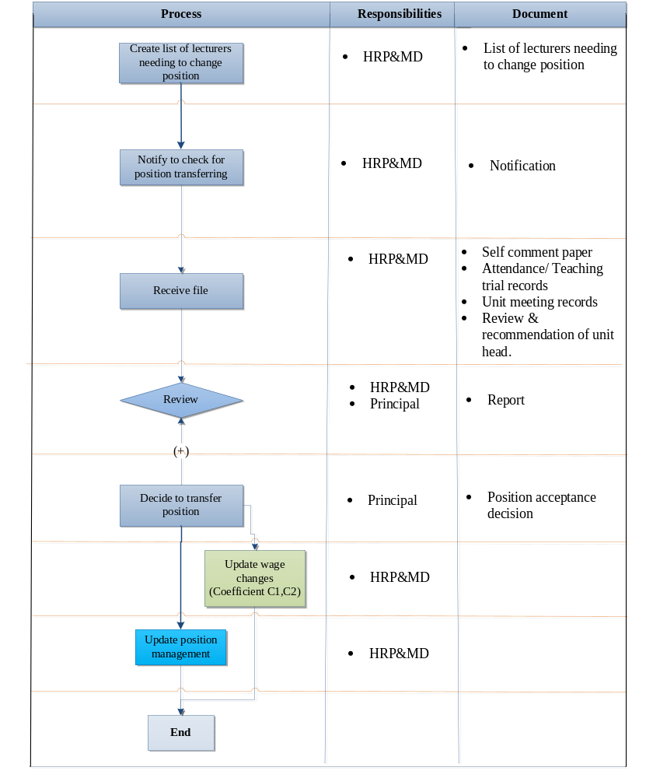
Figure 7: Process of Lecturer Probation Management
            - Description
This function allows user to manage store information about position changes of probationary faculty. This function includes:
Refer to: [HRM] InformationCategories.xlsTTC&TTMR2. 2.2.1
            - Scenario
Scenario
Assumption | System allows user to change position
Actor | Staff of HRP&MD
Step | - Log in to the System  - Choose Personal Information Management  - Choose Expanded information  - Choose Lecturer Probation Management  - Choose probationary faculty  - Change information  - Click save

          - Staff Internship Management
This function allows user to track staff internship progress (duration: 30 days for general worker, 60 days for skilled personnel)
            - Business Process
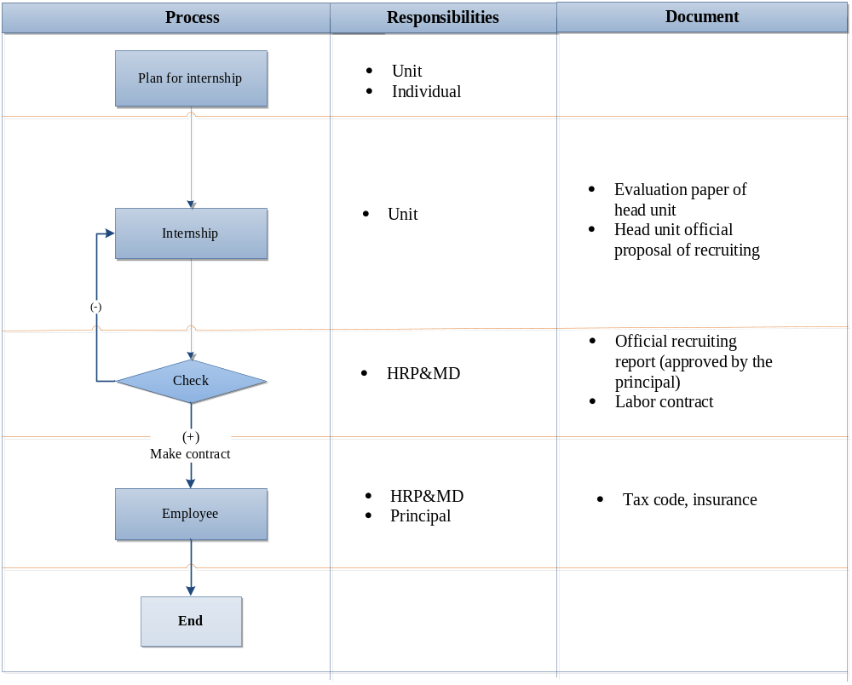 Figure 10: Staff internship management process
            - Description
Refer to: [HRM] InformationCategories.xlsTTC&TTMR 2.2.2.2
            - Scenario
Scenario
Assumption | System allow user to change position
Actor | Staff of HRP&MD
Step | - Log in to the System  - Choose Personal Information Management  - Choose Expanded information  - Choose Staff Internship Management  - Choose staff  - Input information  - Click save
          - Lecturer Position Management
This function allows user to create notification, transferring position profile according to the Ministry and State.
            - Business Process
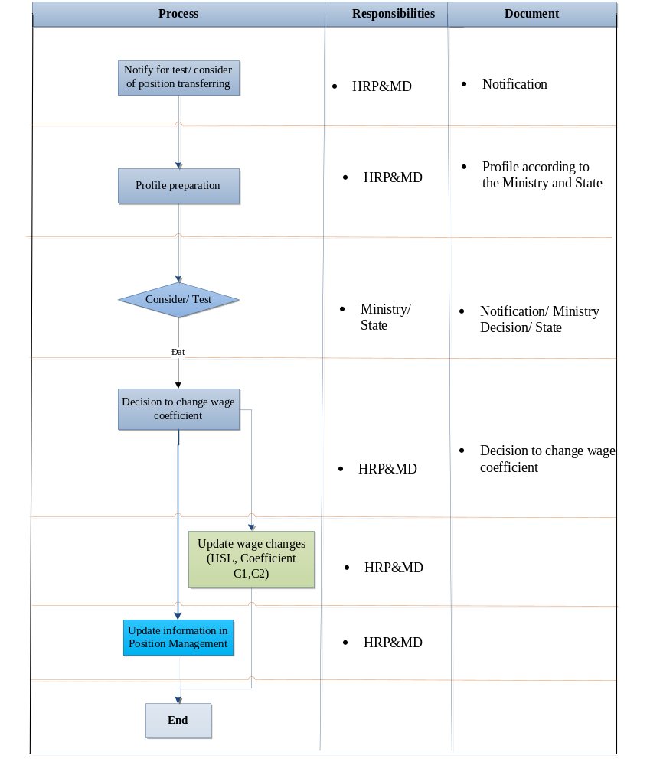
Figure 6: Lecturer Position Management process
            - Description
Refer to: [HRM] InformationCategories.xlsTTC&TTMR 2.2.3
This function allows user to store lecturer position changes information.
            - Scenario
Scenario
Assumption | System allows user to update lecturer position changes information
Actor | Staff of HRP&MD
Step | - Log in to the System  - Choose Personal Information Management  - Choose Expanded information  - Choose Lecturer Position Management  - Input information  - Click save

          - Training Managing
This function allows user to record courses, training results.
            - Business Process
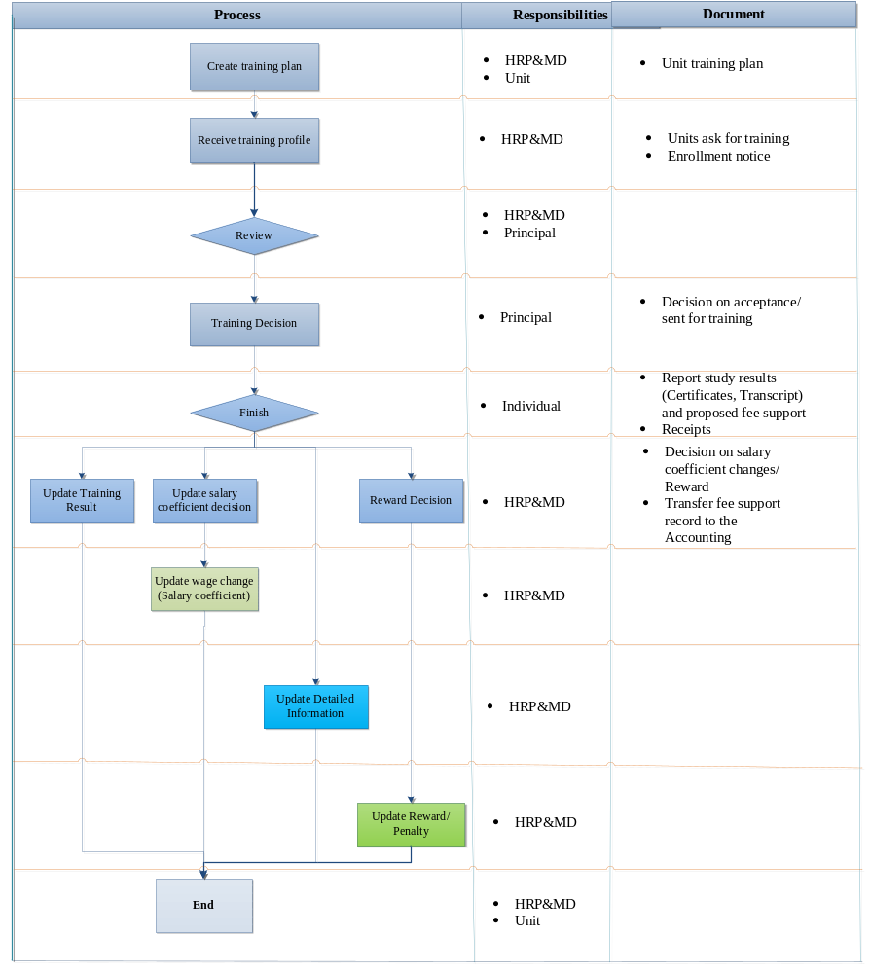
Figure 9: Training Management Process
            - Description of External Training Management
Refer to: [HRM] InformationCategories.xlsTTC&TTMR 2.2.4.1

            - Description of Internal Training Management
Refer to: [HRM] InformationCategories.xlsTTC&TTMR 2.2.4.2
            - Scenario
Scenario 1
Assumption | System allows user to update information in training management of employee Expanded Information.
Actor | Staff of HRP&MD
Step | - Log in to the System  - Choose Personal Information Management  - Choose Training Management  - Input information  - Click save
Scenario 2
Assumption | System allows user to update information in training management of Expanded Information for employee who finished training and rewarded.
Actor | Staff of HRP&MD
Step | - Log in to the System  - Choose Personal Information Management  - Choose Training Management  - Input information  - Click save
Ghi chú: | - If receive accepted certificates, user must update information in Award/ Penalty Management  - Choose Award Management  - Input information  1.4 Click save

          - Facilitate Management
This function allows user to record information about facilitate provided to employee.
            - Description
Refer to: [HRM] InformationCategories.xlsTTC&TTMR 2.2.5
            - Scenario

Scenario
Assumption | System allows user to manage facilitate delivered to employee.
Actor | Staff of Human Resource Planning and Managing Department
Step | - Log in to the System  - Choose Personal Information Management  - Choose Expanded Information Management  - Choose Facilitate Management  - Input information  - Click save

          - Award Management
This function allows user to record employee award progress.
            - Description
Refer to: [HRM] InformationCategories.xlsTTC&TTMR 2.2.6.1
            - Scenario
Scenario
Assumption | System allows user to record employee award progress
Actor | Staff of Human Resource Planning and Managing Department
Step | - Log in to the System  - Choose Personal Information Management  - Choose Expanded Information  - Choose Award, Penalty, Emulation Management  - Choose Award Management  - Input information  - Click save

          - Penalty Management
This function allows user to record employee penalty progress.
            - Description
Refer to: [HRM] InformationCategories.xlsTTC&TTMR 2.2.6.2
            - Scenario
Scenario
Assumption | System allows user to record employee penalty progress
Actor | Staff of Human Resource Planning and Managing Department
Step | - Log in to the System  - Choose Personal Information Management  - Choose Expanded information  - Choose Award, Penalty, Emulation Management  - Choose Penalty Management  - Input information  - Click save

          - Emulation Management
This function allow user to record employee emulations and award level
            - Description
Refer to: [HRM] InformationCategories.xlsTTC&TTMR2.2.6.3
            - Scenario
Scenario
Assumption | System allows user to record employee emulations and award level
Actor | Staff of Human Resource Planning and Managing Department
Step | - Log in to the System  - Choose Personal Information Management  - Choose Expanded Information Management  - Choose Award, Penalty, Emulation Management  - Choose Emulation Management  - Input information  - Click save

          - Income Element Progress Management
This function allows user to monitoring income element progress of an employee.
            - Business Process
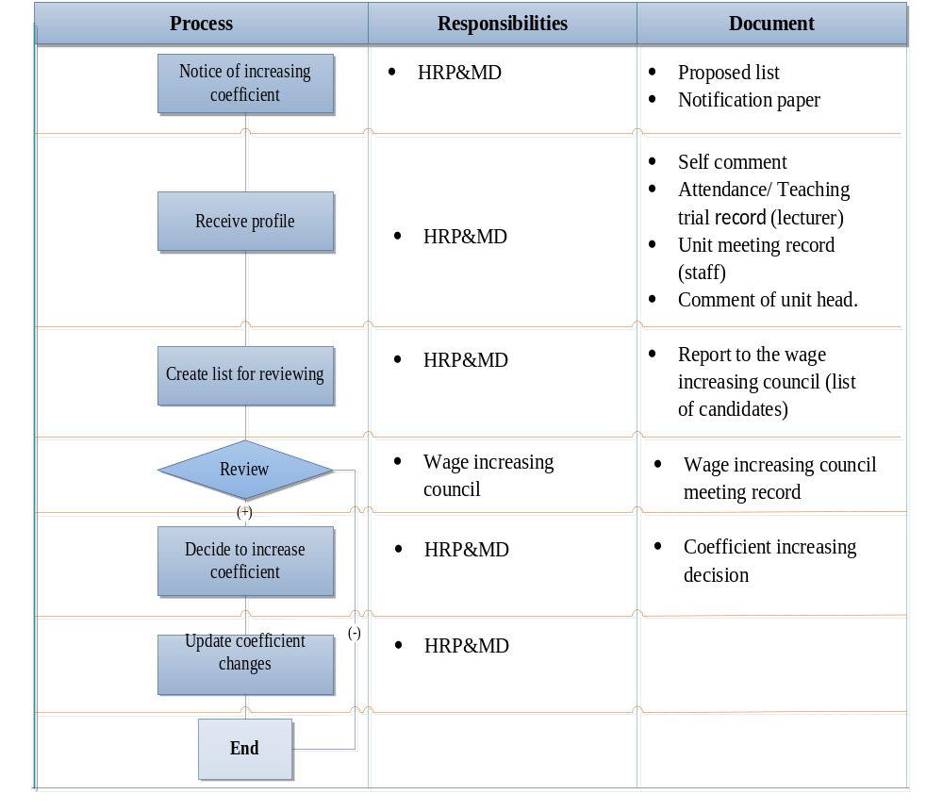
Figure 8: Income Change Factors Management Process
            - Create Notification for Increasing Income
User will create a notification for increasing employee income and related unit will give comments so that the council may consider accepting.
            - Description of Recording Income Element Progress
This function allows user to record information about employee Income Element Progress.
Refer to: [HRM] InformationCategories.xlsTTC&TTMR 2.2.7
            - Scenario
Scenario
Assumption | System allows user to change wage change in Expanded Information Management
Actor | Staff of HRP&MD
Step | - Log in to the System  - Choose Personal Information Management  - Choose Expanded information  - Choose Income Element Progress Management  - Input information  - Click save

          - Profile Management
This function allows user to record information in science profile of an employee.
            - Description
Refer to: [HRM] InformationCategories.xlsTTC&TTMR 2.2.8
            - Scenario

Scenario
Assumption | System allows user to update Expanded information about research, article, curriculum document and Ph.D., Master thesis guideline
Actor | Lecturer, Staff
Step | - Log in to the System  - Choose Personal Information Management  - Choose Expanded information  - Choose Thread  - Input information  - Save  - Choose Article  - Input information  - Save  - Curriculum/ Materials  - Input information  - Save  - Works  - Input information  - Save  - Ph.D., Master thesis guideline  - Input information  - Click save  - Student research guideline  - Input information  - Click save

          - Trade Union Management
This function allows user to update employee information in trade union.
            - Description
Refer to: [HRM] InformationCategories.xlsTTC&TTMR2. 2.9.1
            - Scenario
Scenario
Assumption | System allows user to update expanded information about working progress in trade union.
Actor | Staff of HRP&MD
Step | - Log in to the System  - Choose Personal Information Management  - Choose Expanded information  - Choose Communist Party/ Union  - Choose Communist Party Management  - Input information  - Save

          - Union Management
This function allows user to record changes of employee in union.
            - Description
Refer to: [HRM] InformationCategories.xlsTTC&TTMR 2.2.9.2
            - Scenario
Scenario
Assumption | System allows user to update in expanded information about employee working progress in union.
Actor | Staff of HRP&MD
Step | - Log in to the System  - Choose Personal Information Management  - Choose Expanded information  - Choose Communist Party/ Union Management  - Choose Union Management  - Input information  - Save

          - Communist Party Management
This function allows user to record changes of employee in trade union.
            - Description
Refer to: [HRM] InformationCategories.xlsTTC&TTMR 2.2.9.3
            - Scenario
Scenario
Assumption | System allows user to update expanded information about working progress in trade union
Actor | Staff of HRP&MD
Step | - Log in to the System  - Choose Personal Information Management  - Choose Expanded information  - Choose Communist Party/ Union Management  - Choose Communist Party Management  - Input information  - Save

        - Anticipated Users and Stakeholders
Actor | Roles and Responsibilities
Staff | Review, update information:  - Research  - Published article  - Curriculum and materials  - Work  - Ph.D., Master thesis guideline  - Student scientific research guideline
Staff of HRP&MD | - Create recruitment plan  - Labor Management, employee assessment  - Review, update Personal Information Management  - Statistics and reports information of the school staff  - Income management
Unit | - Create recruitment plan  - Labor Management, employee assessment
Administrator | System management:  - Create user  - User authorization

        - Proposed Supported Environment
- HRM system is developed as an application working in Windows, especially in Window XP/Vista/7
- Computers transfer information with each other via local network in a campus and fiber cable among campuses.
- Bilingual, English and Vietnamese
- Install Microsoft database management in server.

Summary of Impacts

Operational Impacts
- When operating HRM, Staffs of HRP&MD will input candidate information. Then, each unit, individual must update information for easily managing.
- Administrator must authenticate user.

Organizational Impacts
- Adding and removing jobs when using new software: due to reducing unnecessary works in business process, so that we can arrange reasonable human resource into works, and saving time when using software.
- User manual: We must guide them when getting requirement in addition to deliver user manual together with completed software.

Impacts during Development
- Users will participate in requirement meetings. We plan to meet customers once a week for completely getting requirements.
- Stakeholders must provide template about contract, report, insurance, detailed information about business, and required problems when using software.
- While not using the proposed system, users can problems when using the current system, and desired solutions.
- The proposed system will be put on the test with customers and among team several times while developing Personal Information Management.
- About supporting and maintaining system, the development team plan to maintain system after releasing two weeks. During maintaining, we will check, edit functions following customers’ reasonable requests.

Analysis of the Proposed System
Difference ideas about improvements, disadvantages, limitations, and advantages will be accentuated in this section.

Summary of Improvements
- Simplify and enhance processing information so that storing personal information will be much more easily and convenience.
- Create reports and statistics quickly and correctly.
- The proposed system must support authorizing user to guaranty data safety and help user to manage and react with problems quickly.
- Create templates, categories.
- Optimize human resources, reduce paper work, increase productivity.
- Configure and re-modify human resource structure: create categories about units, organizations, position etc.
- Store employee personal information: profile, working progress...
- Track labor contract and insurance: Labor contract management, and insurance.
- Labor and income management: Labor management, assessment management, income management...
- Training management, recruiting, appointment
- The proposed system helps users store and manage data perfectly so that they can search, backup, restore, report etc. quickly and avoid losing data as usual.
- Many users can change and edit data but the data still maintain consistency.
- Help users input data in a more attractive way

Disadvantages and Limitations
- The proposed system may change current business process. Although processes are improved, it will take a short time for customers to get accustom to work in a new environment.
- The developing progress must be fully secure from leaking information gathered from effort and experience of VLU leaders about managing human resource.

Alternatives and Trade-offs Considered
- Current system is a manual one, so that it does not require any modern computer for managing.
- It costs some funds to deploy the proposed system.
- To use the proposed system, users are required to have management skills and new techniques in using management software.

